





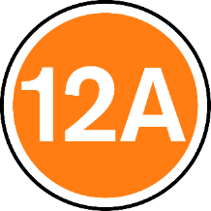
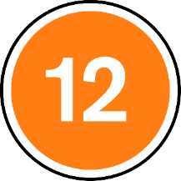


Lesson 1: Resource 2
Matching activity – support
For 15 year olds and over
For most people (but some scenes might not be suitable for younger children and might be a bit upsetting for some children)—parents and carers should check the film first)
For 12 year olds and over. Under 12s can watch if accompanied by an adult at the cinema.
For adults only
For everyone (universal) — should be suitable for children aged four years and over

