

Supporting pupils with medical conditions policy

July 2026

North Wheatley C of E Primary School Head Teacher: Mrs Ruddlesdin

Sturton Road, South Wheatley, Retford Notts DN22 9DH Tel: (01427) 880409
Email: head@northwheatley.notts.sch.uk

Approved on: | July 2026
Last reviewed on: | May 2024
Next review due by: | Summer 2028

Contents
- Aims 2
- Legislation and statutory responsibilities 3
- Roles and responsibilities 3
- Equal opportunities 4
- Being notified that a child has a medical condition 4
- Individual healthcare plans 5
- Managing medicines 6
- Emergency procedures 7
- Training 7
- Record keeping 8
- Liability and indemnity 8
- Complaints 8
- Monitoring arrangements 8
- Links to other policies 8

Aims
This policy aims to ensure that:
  - Pupils, staff and parents understand how our school will support pupils with medical conditions
  - Pupils with medical conditions are properly supported to allow them to access the same education as other pupils, including school trips and sporting activities. Medical conditions may include both physical and mental health needs.
The governing board will implement this policy by:
  - Making sure sufficient staff are suitably trained
  - Making staff aware of pupil’s condition, where appropriate
  - Making sure there are cover arrangements to ensure someone is always available to support pupils with medical conditions
  - Providing supply teachers with appropriate information about the policy and relevant pupils
  - Developing and monitoring individual healthcare plans (IHPs)

The named person with responsibility for implementing this policy is the Headteacher

Legislation and statutory responsibilities

This policy meets the requirements under Section 100 of the Children and Families Act 2014, which places a duty on governing boards to make arrangements for supporting pupils at their school with medical conditions.
It is also based on the Department for Education’s statutory guidance: Supporting pupils at school with medical conditions.

Roles and responsibilities

The governing board
The governing board has ultimate responsibility to make arrangements to support pupils with medical conditions. The governing board will ensure that sufficient staff have received suitable training and are competent before they are responsible for supporting children with medical conditions.

The headteacher
The headteacher will:
    - Make sure all staff are aware of this policy and understand their role in its implementation
    - Ensure that there is a sufficient number of trained staff available to implement this policy and deliver against all individual healthcare plans (IHPs), including in contingency and emergency situations
    - Take overall responsibility for the development of IHPs
    - Contact the school nursing service in the case of any pupil who has a medical condition that may require support at school, but who has not yet been brought to the attention of the school nurse
    - Ensure that systems are in place for obtaining information about a child’s medical needs and that this information is kept up to date

Staff
Supporting pupils with medical conditions during school hours is not the sole responsibility of one person. Any member of staff may be asked to provide support to pupils with medical conditions, although they will not be required to do so. This includes the administration of medicines.
Those staff who take on the responsibility to support pupils with medical conditions will receive sufficient and suitable training, and will achieve the necessary level of competency before doing so.

Teachers will take into account the needs of pupils with medical conditions that they teach. All staff will know what to do and respond accordingly when they become aware that a pupil with a medical condition needs help.

Parents
Parents will:
    - Provide the school with sufficient and up-to-date information about their child’s medical needs
    - Be involved in the development and review of their child’s IHP and may be involved in its drafting
    - Carry out any action they have agreed to as part of the implementation of the IHP e.g. provide medicines and equipment

Pupils
Pupils with medical conditions will often be best placed to provide information about how their condition affects them. Pupils should be fully involved in discussions about their medical support needs and contribute as much as possible to the development of their IHPs. They are also expected to comply with their IHPs.

Equal opportunities
Our school is clear about the need to actively support pupils with medical conditions to participate in school trips and visits, or in sporting activities, and not prevent them from doing so.
The school will consider what reasonable adjustments need to be made to enable these pupils to participate fully and safely on school trips, visits and sporting activities.
Risk assessments will be carried out so that planning arrangements take account of any steps needed to ensure that pupils with medical conditions are included. In doing so, pupils, their parents and any relevant healthcare professionals will be consulted.

Being notified that a child has a medical condition
When the school is notified that a pupil has a medical condition, the process outlined below will be followed to decide whether the pupil requires an IHP.
The school will make every effort to ensure that arrangements are put into place within 2 weeks, or by the beginning of the relevant term for pupils who are new to our school.

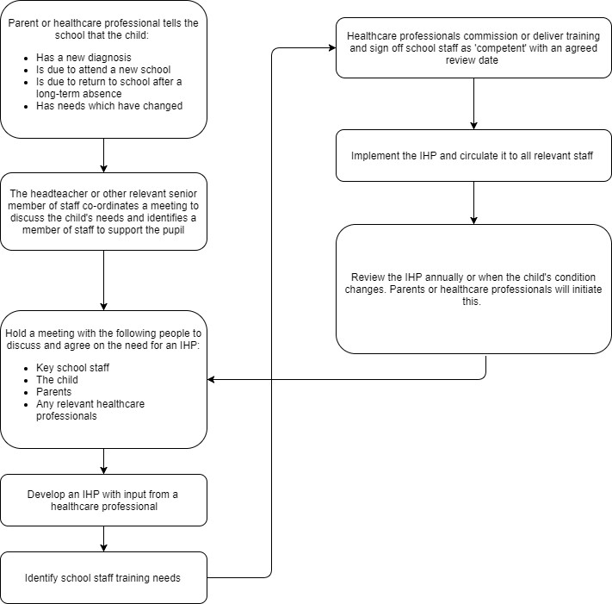

Individual healthcare plans
The headteacher has overall responsibility for the development of IHPs for pupils with medical conditions. Plans will be reviewed at least annually, or earlier if there is evidence that the pupil’s needs have changed. Plans will be developed with the pupil’s best interests in mind and will set out:
  - What needs to be done
  - When
  - By whom
Not all pupils with a medical condition will require an IHP. It will be agreed with parents when an IHP would be inappropriate or disproportionate. This will be based on evidence. If there is not a consensus, the headteacher will make the final decision.
Plans will be drawn up in partnership with the school and parents on the pupil’s specific needs. The pupil will be involved wherever appropriate.
IHPs will be linked to, or become part of, any Education, Health and Care Plan (EHCP). If a pupil has SEN but does not have a statement or EHC plan, the SEN will be mentioned in the IHP.

The level of detail in the plan will depend on the complexity of the child’s condition and how much support is needed. The Headteacher will consider the following when deciding what information to record on IHPs:
  - The medical condition, its triggers, signs, symptoms and treatments
  - The pupil’s resulting needs, including medication (dose, side effects and storage) and other treatments, time, facilities, equipment, testing, access to food and drink where this is used to manage their condition, dietary requirements and environmental issues, e.g. crowded corridors, travel time between lessons
  - Specific support for the pupil’s educational, social and emotional needs. For example, how absences will be managed, requirements for extra time to complete exams, use of rest periods or additional support in catching up with lessons, counselling sessions
  - The level of support needed, including in emergencies. If a pupil is self-managing their medication, this will be clearly stated with appropriate arrangements for monitoring
  - Who will provide this support, their training needs, expectations of their role and confirmation of proficiency to provide support for the pupil’s medical condition from a healthcare professional, and cover arrangements for when they are unavailable
  - Who in the school needs to be aware of the pupil’s condition and the support required
  - Arrangements for written permission from parents and the headteacher for medication to be administered by a member of staff, or self-administered by the pupil during school hours
  - Separate arrangements or procedures required for school trips or other school activities outside of the normal school timetable that will ensure the pupil can participate, e.g. risk assessments
  - Where confidentiality issues are raised by the parent/pupil, the designated individuals to be entrusted with information about the pupil’s condition
  - What to do in an emergency, including who to contact, and contingency arrangements

Managing medicines
Where a pupil has an IHP, medicines will be administered by school staff in line with the IHP.
When a member of staff gives any medication to a pupil on an IHP, they will make a record of when and why the medicine was administered. The log is kept in the pupil's personal file in the office or in the medical bag in their classroom, depending on the medical need and storage of the medicine. Where a device is used to administer medication (such as a diabetic pump) the family and school must agree if there will be a separate log or if this is recorded electronically. If it is agreed this will be recorded electronically then this should be recorded in the child’s IHP.
Where a child doesn’t have an IHP but has a short-term medical need or prescription that needs medicine to be stored and administered in school, then the parent should complete a form stating the following:
- What medicine is needed
- Why it is needed
- When it needs to be taken (time/s of day)
- How it needs to be taken
This form is kept in the office and on the school website so that parents can access in school or home. The form has space for staff to log when the medicine has been taken. This form is either kept in the office (for locked away medicine) or in the staffroom by the medicine fridge (for refrigerated medicine). The class teacher and relevant staff are informed of any short-term medicines and the times at which they need to be administered.
The school will only accept medicines that are:
  - In-date
  - Labelled
  - Provided in the original container, as dispensed by the pharmacist, and include instructions for administration, dosage and storage
The school will accept insulin that is inside an insulin pen or pump rather than its original container, but it must be in date.
All medicines will be stored safely. Pupils will be informed about where their medicines are at all times and be able to access them immediately. Medicines and devices such as asthma inhalers, blood glucose testing meters and adrenaline pens will always be readily available to pupils and not locked away. Asthma inhalers are kept in florescent yellow bags in each classroom. These are displayed clearly in each classroom so they can be accessed by any pupil or child in an emergency. The school maintains an asthma register and holds an emergency salbutamol inhaler in accordance with current guidance.
Medicines will be returned to parents to arrange for safe disposal when no longer required.
It is the parents/carers responsibility to check and ensure that medicine provided to school is in-date.
The school maintains arrangements for pupils at risk of anaphylaxis, ensuring that adrenaline auto-injectors are readily accessible and that relevant staff receive appropriate training.

Controlled drugs
Controlled drugs are prescription medicines that are controlled under the Misuse of Drugs Regulations 2001 and subsequent amendments, such as morphine or methadone.
All controlled drugs are kept in a secure cupboard in the school office and only named staff have access.
Controlled drugs will be easily accessible in an emergency and a record of any doses used and the amount held will be kept.

  - Administering medicine on a school trip
The school may administer non-prescription medicines on educational visits where parental consent has been obtained and the medicine complies with this policy.
We will only give non-prescription medicine to a pupil on a trip if:
- We have received prior written consent from the pupil's parents/carers (EV4 form)
- It’s in line with the rest of the school policy (in labeled container, in date etc.)
- Staff have checked, and received parental confirmation, that the pupil has previously used the medicine without any negative effect
If staff provide a non-prescribed medicine to pupils, they should:
- Make a record for each pupil, explaining what medicine has been administered and when (recorded on form as detailed above)
- Inform the pupil’s parents/carers

Pupils managing their own needs
Pupils who are competent will be encouraged to take responsibility for managing their own medicines and procedures. This will be discussed with parents and it will be reflected in their IHPs.
Pupils will be allowed to carry their own medicines and relevant devices wherever possible (such as children with diabetes). Staff will not force a pupil to take a medicine or carry out a necessary procedure if they refuse, but will follow the procedure agreed in the IHP and inform parents so that an alternative option can be considered, if necessary.

Where a child has a short-term medical need (such as a prescription) they should be encouraged to take responsibility for managing their own medicines if deemed competent to do so. All medicines will remain stored in the office or relevant place. A form to agree to self-administration will be signed by the parent and a staff member will observe to ensure the medicine has been taken properly and logged on the self-administration form.

Wherever possible, allow pupils to carry their own medicines and relevant devices, or to access their medicines for self-administration quickly and easily.

If a pupil refuses to take medicine or carry out a necessary procedure: You shouldn’t force them to do so, but follow the procedure agreed in their individual healthcare plan
Inform the parents or carers so you can consider alternative options

Unacceptable practice
School staff should use their discretion and judge each case individually with reference to the pupil’s IHP, but it is generally not acceptable to:
    - Prevent pupils from easily accessing their inhalers and medication, and administering their medication when and where necessary
    - Assume that every pupil with the same condition requires the same treatment
    - Ignore the views of the pupil or their parents
    - Ignore medical evidence or opinion (although this may be challenged)
    - Send children with medical conditions home frequently for reasons associated with their medical condition or prevent them from staying for normal school activities, including lunch, unless this is specified in their IHPs
    - If the pupil becomes ill, send them to the school office or medical room unaccompanied or with someone unsuitable
    - Penalise pupils for their attendance record if their absences are related to their medical condition,
e.g. hospital appointments
    - Prevent pupils from drinking, eating or taking toilet or other breaks whenever they need to in order to manage their medical condition effectively
    - Require parents, or otherwise make them feel obliged, to attend school to administer medication or provide medical support to their child who has an IHP, including with toileting issues. No parent should have to give up working because the school is failing to support their child’s medical needs
    - Prevent pupils from participating, or create unnecessary barriers to pupils participating in any aspect of school life, including school trips, e.g. by requiring parents to accompany their child
    - Administer, or ask pupils to administer, medicine in school toilets

Emergency procedures
Staff will follow the school’s normal emergency procedures (for example, calling 999). All pupils’ IHPs will clearly set out what constitutes an emergency and will explain what to do.
If a pupil needs to be taken to hospital, staff will stay with the pupil until the parent arrives, or accompany the pupil to hospital by ambulance.

Training
Staff who are responsible for supporting pupils with medical needs will receive suitable and sufficient training to do so.
The training will be identified during the development or review of IHPs. Staff who provide support to pupils with medical conditions will be included in meetings where this is discussed.
The relevant healthcare professionals will lead on identifying the type and level of training required and will agree this with the Headteacher. Training will be kept up to date.
Training will:
  - Be sufficient to ensure that staff are competent and have confidence in their ability to support the pupils
  - Fulfil the requirements in the IHPs
  - Help staff to have an understanding of the specific medical conditions they are being asked to deal with, their implications and preventative measures
Healthcare professionals will provide confirmation of the proficiency of staff in a medical procedure, or in providing medication.
All staff will receive training so that they are aware of this policy and understand their role in implementing it, for example, with preventative and emergency measures so they can recognise and act quickly when a problem occurs. This will be provided for new staff during their induction.

Record keeping
Written records are kept of all medicine administered to pupils. Parents will be informed if their pupil has been unwell at school.
IHPs are kept in a readily accessible place which all staff are aware of.

Liability and indemnity
The governing board will ensure that the appropriate level of insurance is in place and appropriately reflects the school’s level of risk.

Complaints
Parents with a complaint about their child’s medical condition should discuss these directly with the Headteacher in the first instance. If the Headteacher cannot resolve the matter, they will direct parents to the school’s complaints procedure.

Monitoring arrangements
This policy will be reviewed and approved by the governing board every two years or sooner if needed.

Links to other policies
This policy links to the following policies:
  - Accessibility plan
  - Complaints
  - Equality information and objectives
  - First aid
  - Health and safety
  - Safeguarding
  - Special educational needs information report and policy

