At North Wheatley C of E Primary, we understand that we are all ‘The SAME but DIFFERENT too’.

Our PSHE Reading Spine features a range of carefully selected books that support with the teaching of the 9 Protected Characteristics across all key stages. At North Wheatley, we pride ourselves on our wonderful array of books that become the ‘windows and mirrors’ into the wider world. Through stories and discussions, we can explore, experience and appreciate our wonderfully diverse world.

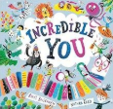  Incredible You | Disability  Race  Ethnicity
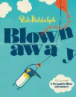  Blown Away | Diversity
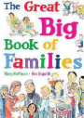  The Great Big Book of Families | Race  Ethnicity  Disability  Sexual orientation  Pregnancy and maternity
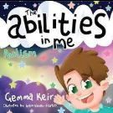  The Abilities in Me – Autism | Disability
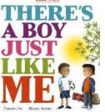  There’s a Boy Just Like Me | Race  Ethnicity
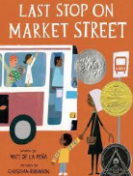  Last Stop on Market Street | Race  Ethnicity
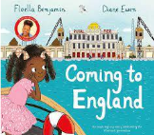  Coming to England | Race  Ethnicity
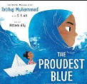  My Proudest Blue | Religion and belief  Race  Ethnicity
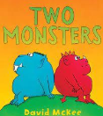  Two Monsters | Age  Race  Ethnicity
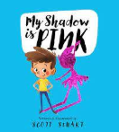  My Shadow is Pink | Gender  Gender reassignment
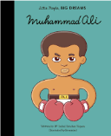  Little People Big Dreams  Muhammad Ali | Race  Ethnicity
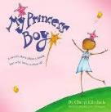  My Princess Boy | Gender  Gender reassignment
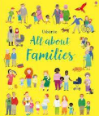  All About Families | Marriage  Gender  Race  Sexual orientation
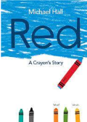  Red – A Crayons Story | Gender  Sexual orientation  Gender Reassignment
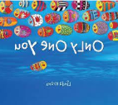
Only One You

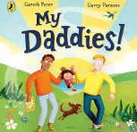  My Daddies | Sexual orientation
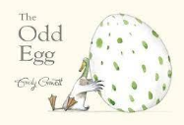
The Odd Egg

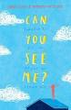  Can you See Me | Disability
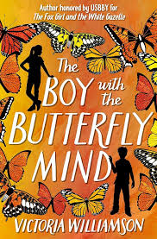  The Boy with the Butterfly Mind | Disability
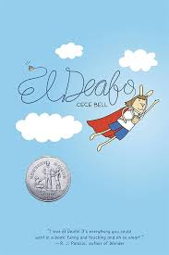  El Deafo | Disability
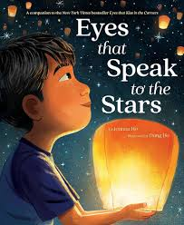  Eyes that Speak to the Stars | Race
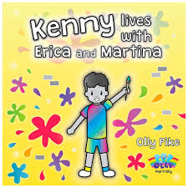  Kenny Lives with Erica and Martina | Sexual orientation
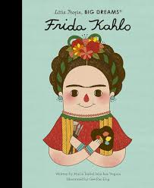  Frida Kahlo Little People Big Dreams | Disability
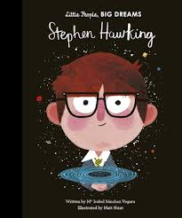  Steven Hawking  Little People Big Dreams | Disability
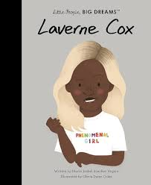  Laverne Cox  Little People Big Dreams | Race  Sexual orientation
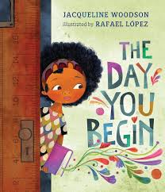  The Day you Begin | Race
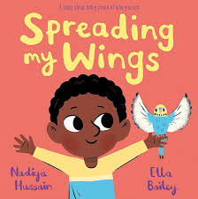  Spreading my Wings | Race
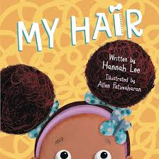  My Hair | Race
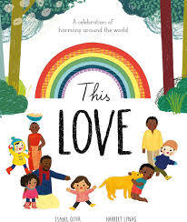  This Love | Sexual orientation
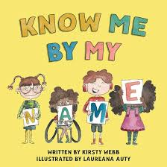  Know me by my Name | Disability
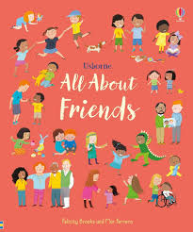  All About Friends | Age  Disability  Gender  Race  Religion and belief
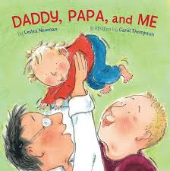  Daddy, Papa and Me | Sexual orientation  Marriage
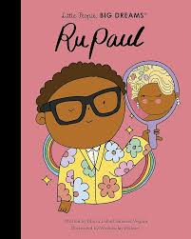  RuPaul  Little People Big Dreams | Sexual orientation
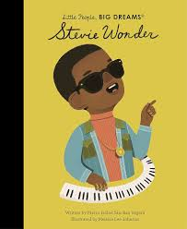  Stevie Wonder  Little People Big Dreams | Disability
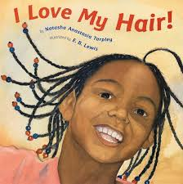  I Love My Hair | Race

